## Supplemental Methods

Date report generated: September 16, 2019

### Instrumentation

Imagery was captured using a DJI Zenmuse X3 RGB camera (DJI 2015a) and a Micasense RedEdge3 5-band multispectral camera (Micasense 2015). We mounted both of these instruments simultaneously on a DJI Matrice 100 aircraft (DJI 2015b) using the DJI 3-axis stabilized gimbal for the Zenmuse X3 camera and a Micasense angled fixed mount for the RedEdge3 camera. The gimbal and the angled fixed mount ensured both instruments were nadir-facing during image capture. Just prior to or after image capture at each site, we calibrated the RedEdge3 camera by taking an image of a calibration panel on the ground in full sun with known reflectance values for each of the 5 narrow bands (Table 1).

Table 1: Reflectance sensitivity of the Micasense Rededge3 camera. The calibration panel value represents the reflectance of the calibration panel for the given wavelength.

|  |  |  |  |  |  |
| --- | --- | --- | --- | --- | --- |
| Band number | Band name | Center wavelength | Band width | Wavelength range | Panel reflectance |
| 1 | blue (b) | 475 | 20 | 465-485 | 0.64 |
| 2 | green (g) | 560 | 20 | 550-570 | 0.64 |
| 3 | red (r) | 668 | 10 | 663-673 | 0.64 |
| 4 | near infrared (nir) | 840 | 40 | 820-860 | 0.6 |
| 5 | red edge (re) | 717 | 10 | 712-722 | 0.63 |

### Flight protocol

Image capture was conducted as close to solar noon as possible to minimize shadow effects (varying primarily due to site accessibility; always within 4 hours, usually within 2 hours). Prior to the aerial survey, two strips of bright orange drop cloth (~100cm x 15cm) were positioned as an “X” over the permanent monuments marking the center of the 5 field plots from Fettig et al. (2019).

For each of the 36 sites (containing 5 plots each), we captured imagery over the surrounding ~40 hectares of forested area using north-south aerial transects. For three sites, we surveyed less surrounding area in order to maintain visual and radio communication with the aircraft during flight which can be obstructed by rolling terrain or non-centrally available takeoff locations.

We preprogrammed aerial transects using Map Pilot for DJI on iOS flight software (hereafter Map Pilot) (DronesMadeEasy 2018). Using the Map Pilot software, we included an altitude adjustment along each aerial transect using a 1-arc-second digital elevation model (Farr et al. 2007) such that the aircraft’s altitude remained approximately constant at 120 meters above ground level in order to maintain consistent ground sampling distance (centimeters on the ground per pixel) in the imagery. Ground sampling distance was approximately 5 cm/px for the Zenmuse X3 RGB camera and approximately 8 cm/px for the RedEdge3 multispectral camera. For this analysis, we dropped 4 sites whose imagery was of insufficient quality to process.

Structure from motion (SfM) processing requires highly overlapping images, especially in densely vegetated areas (Frey et al. 2018). We planned transects with 90% forward overlap and 90% side overlap at 100 meters below the lens. Thus, with flights being at 120 meters above ground level, we achieved slightly higher than 90/90% overlap for objects under 20 meters tall (91.6/91.6% overlap at the ground). Overlap values were based on focal length (3.6mm), sensor width (6.2mm), and image dimension (4000x3000 pixels) parameters of the Zenmuse X3 camera. Images were captured at a constant rate of 1 image every 2 seconds for both cameras. A forward overlap of 90% at 100 meters translates to a flight speed of approximately 6.45 m/s and a side overlap of 90% at 100 meters translates to transects approximately 17.2 meters apart. The RedEdge3 camera has a different focal length (5.4mm), sensor width (4.8mm), and image dimension (1280x960 pixels), which translates to image overlap of 80.7/80.7 % at 100m below the lens and 83.9/83.9 % at ground level. Approximately 1900 photos were captured over each 40 hectare survey area for each camera.

### Structure from Motion (SfM) processing

We used structure from motion (SfM) to generate dense point clouds (Figure 1), digital surface models (Figure 2), and orthorectified reflectance maps (Figure 3) for each field site (Frey et al. 2018). We used Pix4Dmapper Cloud to process imagery using parameters ideal for images of a densely vegetated area taken by a multispectral camera. For 29 sites, we processed the RedEdge3 multispectral imagery alone. For three sites, we processed the RGB and the multispectral imagery in the same project to enhance the point density of the resulting point cloud. All SfM projects resulted in a single processing “block,” indicating that all images in the project were optimized and processed together.

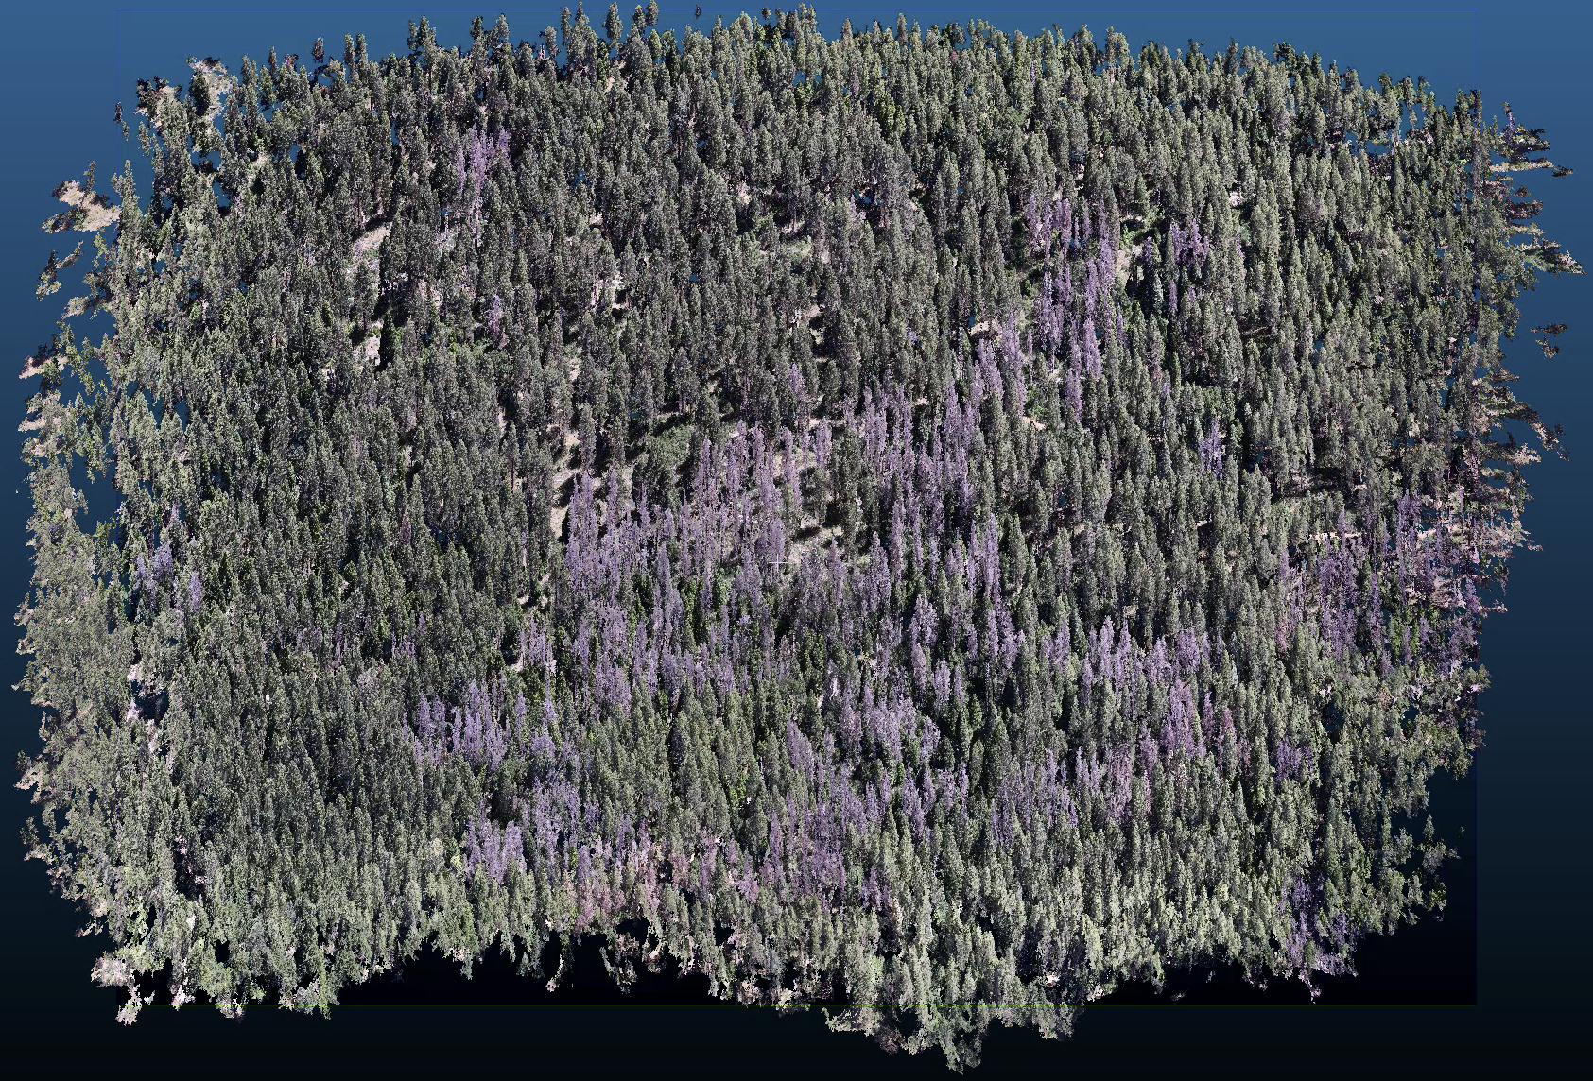

Figure 1: A dense point cloud representing ~40 hectares of forest is generated using Structure from Motion (SfM) processing of ~1900 images. The dense point cloud z- position represents the ground elevation plus the vegetation height.

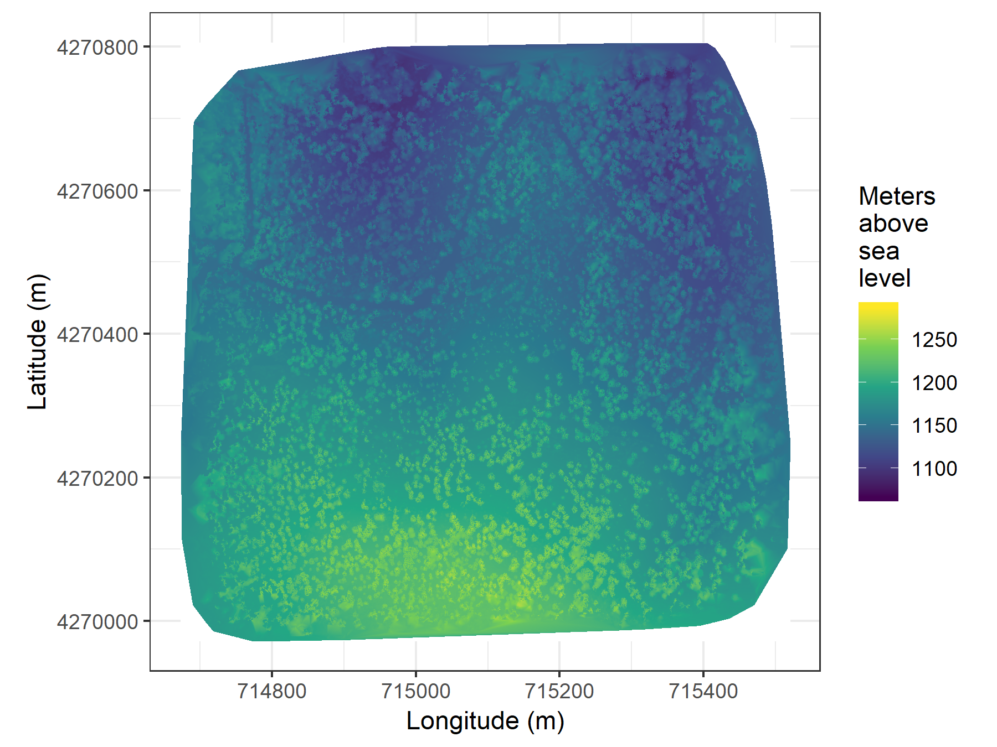

Figure 2: The digital surface model (DSM) is a 2-dimensional representation of the dense point cloud generated using structure from motion (SfM) processing. The DSM represents the ground elevation plus the vegetation height.



Figure 3: The orthomosaic for each of the 32 sites is generated with the Structure from Motion (SfM) processing, showing a top-down view of the whole survey area such that distances between objects in the scene are preserved and can be measured. Depicted is an example red-green-blue orthomosaic for one of the 32 sites covering approximately 40 hectares. The resolution of the original orthophoto is approximately 8cm per pixel, and has been considerably coarsened in this depiction.

### Creating canopy height models

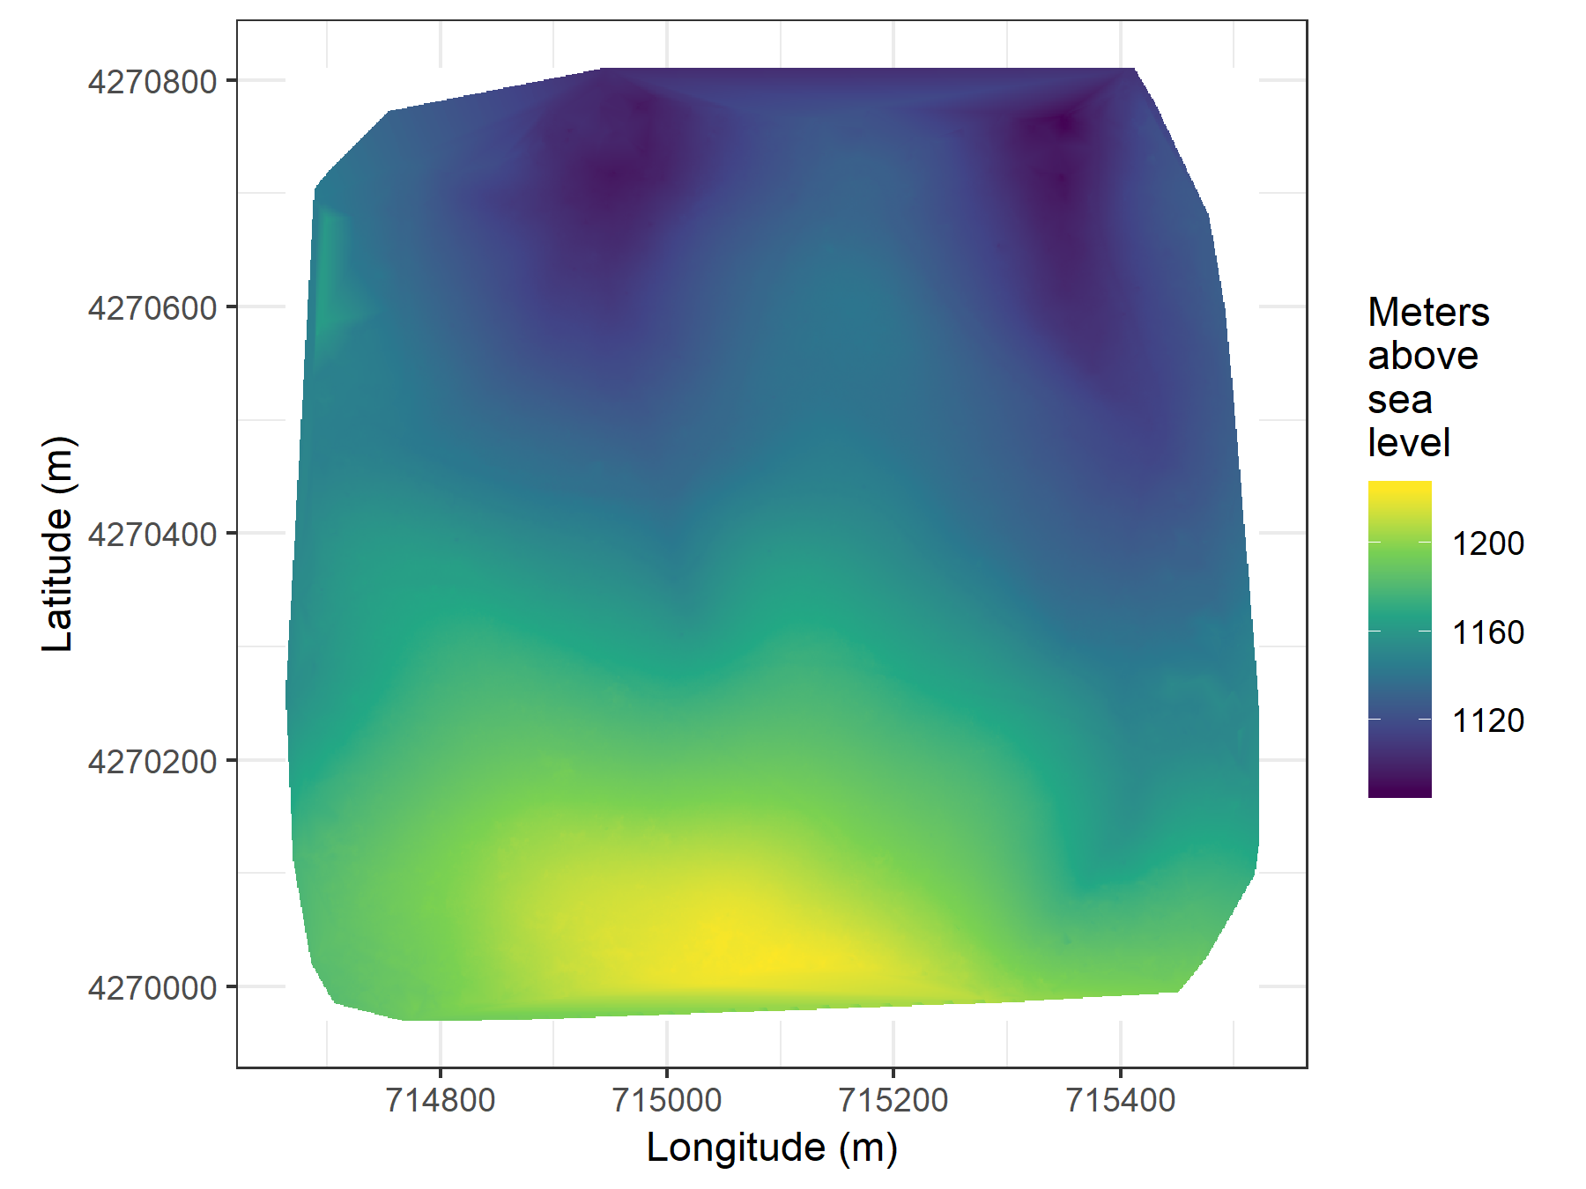

Figure 4: The digital terrain model (DTM) is generated by processing the dense point cloud using the cloth simulation filter algorithm (Zhang et al. 2016), which classifies points as ‘ground’ or ‘not-ground’ and then interpolates the ‘ground’ elevation using Delaunay triangulation for the rest of the dense point cloud footprint. The DTM represents the ground elevation without any vegetation.

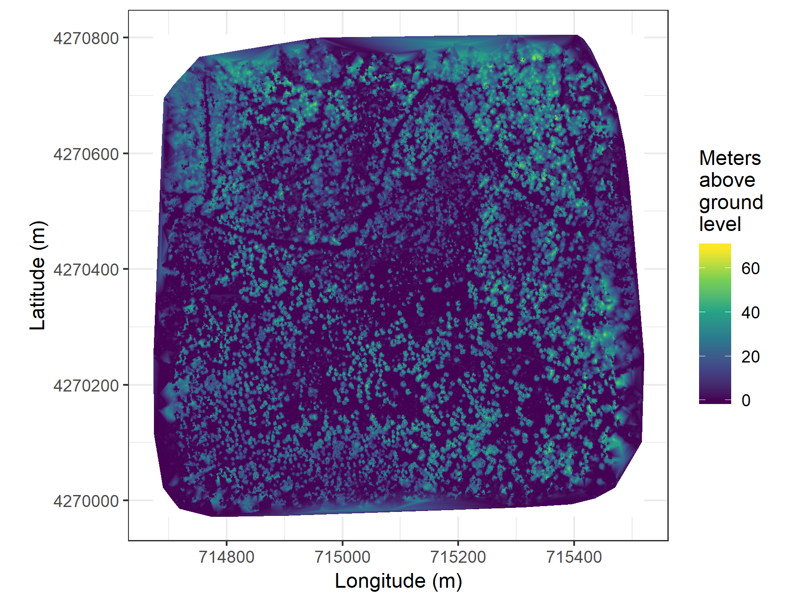

Figure 5: The canopy height model (CHM) is generated by subtracting the digital terrain model from the digital surface model. The CHM represents the height of all of the elevation above ground level.

We classified each survey area’s dense point cloud into “ground” and “non-ground” points using a cloth simulation filter algorithm (Zhang et al. 2016) implemented in the lidR (Roussel et al. 2019) package. We rasterized the ground points using the raster package (Hijmans et al. 2019) to create a digital terrain model (Figure 4) representing the ground underneath the vegetation at 1 meter resolution. We created a canopy height model (Figure 5) by subtracting the digital terrain model from the digital surface model created in Pix4Dmapper.

### Tree detection

We tested a total of 7 automatic tree detection algorithms and a total of 177 parameter sets on the canopy height model or the dense point cloud to locate trees within each site (Table 2). We used 3 parameter sets of a variable window filter using the vwf() function in the ForestTools (Plowright 2018) R package, including the default winFun parameter for the vwf() function as well as the “pines” and “combined” functions from Popescu and Wynne (2004) as the winFun parameter. We used 6 parameter sets of a local maximum filter implemented in lidR. We used 131 parameter sets of the algorithm from Li et al. (2012), which operates on the original point cloud. These parameter sets included those from Shin et al. (2018) and Jakubowski et al. (2013). We used 3 parameter sets of the watershed algorithm implemented in lidR, which is a wrapper for a function in the EBImage package (Pau et al. 2010). We used 3 parameter sets of ptrees (Vega et al. 2014) implemented in lidR (Roussel et al. 2019) and lidRplugins (Roussel 2019) and which operates on the raw point cloud, without first normalizing it to height above ground level (i.e., subtracting the ground elevation from the dense point cloud). We used the default parameter set of the multichm (Eysn et al. 2015) algorithm implemented in lidR (Roussel et al. 2019) and lidRplugins (Roussel 2019). Finally, we used 30 parameter sets of the experimental algorithm lmfx (Roussel 2019).

Table 2: Algorithm name, number of parameter sets tested for each algorithm, and references.

|  |  |  |
| --- | --- | --- |
| Algorithm | Parameter sets tested | Reference(s) |
| li2012 | 131 | Li et al. (2012); Jakubowski et al. (2013); Shin et al. (2018) |
| lmfx | 30 | Roussel (2019) |
| localMaxima | 6 | Roussel et al. (2019) |
| multichm | 1 | Eysn et al. (2015) |
| ptrees | 3 | Vega et al. (2014) |
| vwf | 3 | Plowright (2018) |
| watershed | 3 | Pau et al. (2010) |

### Map ground data

Each orthorectified reflectance map was inspected to locate the 5 orange “X”s marking the center of the field plots (Figure 3), though some plot centers were obscured due to dense interlocking tree crowns or because a plot center was located directly under a single tree crown. We were able to locate 110 out of 180 field plots and were then able to use these plots for validation of automated tree detection algorithms. We used the sf package (Pebesma et al. 2019) to convert distance-from-center and azimuth measurements of each tree in the ground plots to an x-y position on the SfM-derived reflectance map using the x-y position of the orange X visible in the reflectance map as the center.

### Correspondence of automatic tree detection with ground data

We calculated 7 forest structure metrics for each field plot using the ground data collected by Fettig et al. (2019): total number of trees, number of trees greater than 15 meters, mean height of trees, 25th percentile tree height, 75th percentile tree height, mean distance to nearest tree neighbor, mean distance to 2nd nearest neighbor.

For each tree detection algorithm and parameter set described above, we calculated the same set of 7 structure metrics within the footprint of the validation field plots. We calculated the Pearson’s correlation and root mean square error (RMSE) between the ground data and the aerial data for each of the 7 structure metrics for each of the 177 automatic tree detection algorithms/parameter sets.

For each algorithm and parameter set, we calculated its performance relative to other algorithms as whether its Pearson’s correlation was within 5% of the highest Pearson’s correlation as well as whether its RMSE was within 5% of the lowest RMSE. For each algorithm/parameter set, we summed the number of forest structure metrics for which it reached these 5% thresholds. For automatically detecting trees across the whole study, we selected the algorithm/parameter set that performed well across the most number of forest metrics (Figure 6).



Figure 6: Tree locations are detected using the lmfx (Roussel et al. 2019) treetop detection algorithm on the dense point cloud.

### Segmentation of crowns



Figure 7: Individual crowns are delineated using a marker controlled watershed segmentation algorithm (Meyer and Beucher 1990, Plowright 2018) on the canopy height model (CHM) using the detected tree locations as a priority map. If the algorithm failed to delineate a crown for a tree that was identified in the tree detection step, a circular crown with a 0.5m buffer centered on point location of the detected tree was added as a crown.

We delineated individual tree crowns with a marker controlled watershed segmentation algorithm (Meyer and Beucher 1990) using the detected treetops as markers implemented in the ForestTools package (Plowright 2018). If the automatic segmentation algorithm failed to generate a crown segment for a detected tree (e.g., often snags with a very small crown footprint), a circular crown was generated with a radius of 0.5 meters. If the segmentation generated multiple polygons for a single detected tree, only the polygon containing the detected tree was retained (Figure 7). Image overlap decreases near the edges of the overall flight path, which reduces the quality of the SfM processing in those areas. Thus, we excluded segmented crowns within 35 meters of the edge of the survey area. Given the narrower field of view of the RedEdge3 multispectral camera versus the X3 RGB camera whose optical parameters were used to define the ~40 hectare survey area around each site, as well as the 35 meter additional buffering, the survey area at each site was approximately 30 hectares (Table 3).

We used the velox package (Hunziker 2017) to extract all the pixel values from the orthorectified reflectance map for each of the 5 narrow bands within each segmented crown polygon. Per pixel, we additionally calculated the normalized difference vegetation index (NDVI; Rouse et al. (1973)), the normalized difference red edge (NDRE; Gitelson and Merzlyak (1994)), the red-green index (RGI; Coops et al. (2006)), the red edge chlorophyll index (CIred edge; Clevers and Gitelson (2013)), and the green chlorophyll index (CIgreen; Clevers and Gitelson (2013)). For each crown polygon, we calculated the mean value for each raw and derived reflectance band (5 raw; 5 derived).

### Classification of trees



Figure 8: Each tree is classified as live or dead by extracting the pixel values from the 5 narrow bands of the Rededge3 camera (and 5 derived bands– see methods) in the orthomosaic within each segmented tree crown of the detected trees, taking their mean value, and using those means to predict live/dead status with a boosted logistic regression previously trained on a hand-classified set of segmented crowns from across the study area.



Figure 9: For each live tree, we classified its species using the same means of extracted pixel values across the 5 Rededge3 narrow bands (and 5 derived bands) as predictors in a regularized discriminant analysis previously trained on a hand-classified set of segmented crowns from across the study area.

We overlaid the segmented crowns on the reflectance maps from 20 sites spanning the latitudinal and elevation gradient in the study. Using QGIS, we hand classified 564 trees as live/dead (Figure 8) and as one of 5 dominant species in the study area (*Pinus ponderosa*, *Pinus lambertiana*, *Abies concolor*, *Calocedrus decurrens*, or *Quercus kelloggi*) using the mapped ground data as a guide. We treated all trees classified as ponderosa pine as a “host” tree and all other species as “non-host” trees (Figure 9).

We used all 10 mean values of the reflectance bands for each tree crown polygon to predict whether the hand classified trees were alive or dead using a boosted logistic regression model implemented in the caret package (accuracy of live/dead classification on a withheld test dataset: 97.3%) (Kuhn 2008). For just the living trees, we similarly used all 10 reflectance values to predict the tree species using regularized discriminant analysis implemented in the caret package (accuracy of species classification on a withheld testing dataset: 66.7%; accuracy of WPB host/non-WPB-host (i.e., ponderosa pine versus other tree species) on a withheld testing dataset: 74.4%).

Finally, we used these models to classify all tree crowns in the data set as alive or dead as well as the species of living trees.

### Allometric scaling of height to quadratic mean diameter

We converted the height of each tree determined using the canopy height model to its diameter at breast height, 1.37m (DBH). Using the tree height and DBH ground data from Fettig et al. (2019), we fit a simple linear regression to predict DBH from height for each of the 5 dominant species. Using the model-classified tree species of each segmented tree, we used the corresponding linear relationship for that species to estimate the DBH given the tree’s height. We then calculated the quadratic mean diameter for each 20m x 20m cell as the square root of the average squared diameter of trees within the cell.

### Note on assumptions about dead trees

For the purposes of this study, we assumed that all dead trees were ponderosa pine and were thus host trees for the western pine beetle. This is a reasonably good assumption for our study area, given that Fettig et al. (2019) found that 73.4% of the dead trees in the coincident ground plots were ponderosa pine. The species contributing to the next highest proportion of dead trees was incense cedar which represented 18.72% of the dead trees in the ground plots. Incense cedar is not a potential host of the western pine beetle, and different forest structure/environment conditions can dictate the dynamic between forest insects and their host tree species (Stephenson et al. 2019). While the detected mortality is most likely to be ponderosa pine, it is critical to interpret our results with this known limitation in mind.

### Rasterizing individual tree data

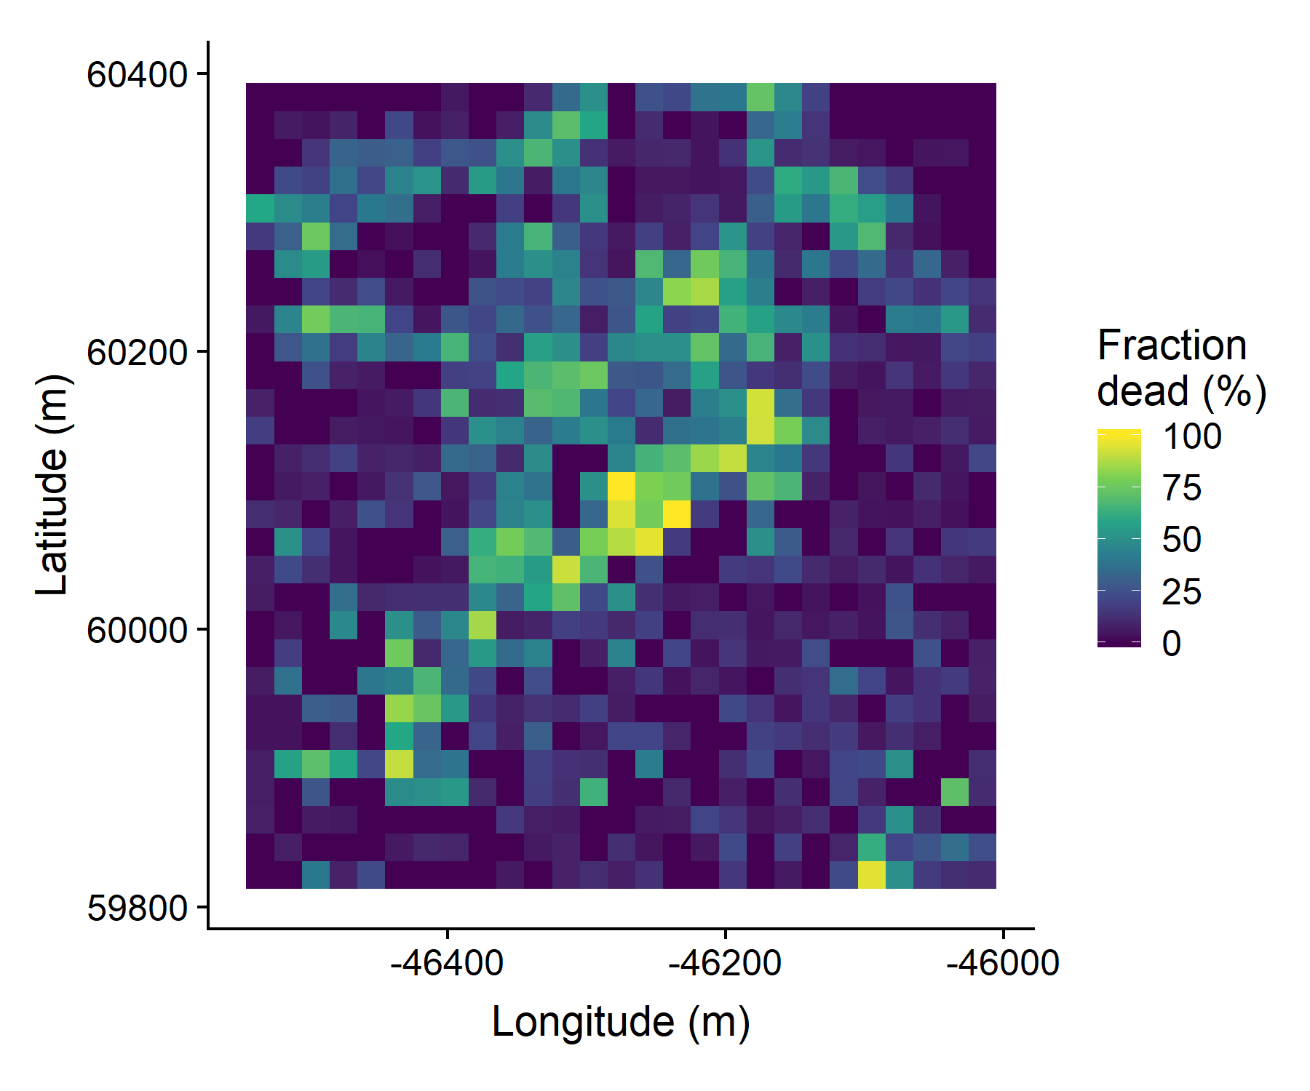

Figure 10: We rasterized the individual tree data by aggregating values to 20m x 20m cells. This example shows the proportion of dead trees per cell for the same example site as in the previous figures.

Because the tree detection algorithms were validated against ground data at the plot level, we rasterized the classified trees at a spatial resolution similar to that of the ground plots (Figure 10). That is, we rasterized the individual tree data to 20m x 20m pixels equaling 400 m2, and the circular ground plots with 11.35m radius covered 404 m2. In each raster cell, we calculated the: number of live trees, number of dead trees, number of ponderosa pine trees, total number of trees (of all species, including ponderosa pine), quadratic mean diameter (QMD) of ponderosa pine trees, and QMD of all trees of any species (overall QMD). We converted the count of ponderosa pine trees and the total tree count to a density measurement of trees per hectare (tpha) by multiplying the counts in each 20m x 20m cell by 25 to create a “host density” and an “overall density” variable per cell.

Clevers, J., and A. Gitelson. 2013. Remote estimation of crop and grass chlorophyll and nitrogen content using red-edge bands on Sentinel-2 and -3. International Journal of Applied Earth Observation and Geoinformation 23:344–351.

Coops, N. C., M. Johnson, M. A. Wulder, and J. C. White. 2006. Assessment of QuickBird high spatial resolution imagery to detect red attack damage due to mountain pine beetle infestation. Remote Sensing of Environment 103:67–80.

DJI. 2015a. Zenmuse X3 - Creativity Unleashed. <https://www.dji.com/zenmuse-x3/info>.

DJI. 2015b. DJI - The World Leader in Camera Drones/Quadcopters for Aerial Photography. <https://www.dji.com/matrice100/info>.

DronesMadeEasy. 2018. ‎Map Pilot for DJI on iOS. <https://itunes.apple.com/us/app/map-pilot-for-dji/id1014765000?mt=8>.

Eysn, L., M. Hollaus, E. Lindberg, F. Berger, J.-M. Monnet, M. Dalponte, M. Kobal, M. Pellegrini, E. Lingua, D. Mongus, and N. Pfeifer. 2015. A benchmark of LiDAR-based single tree detection methods using heterogeneous forest data from the alpine space. Forests 6:1721–1747.

Farr, T. G., P. A. Rosen, E. Caro, R. Crippen, R. Duren, S. Hensley, M. Kobrick, M. Paller, E. Rodriguez, L. Roth, D. Seal, S. Shaffer, J. Shimada, J. Umland, M. Werner, M. Oskin, D. Burbank, and D. Alsdorf. 2007. The Shuttle Radar Topography Mission. Reviews of Geophysics 45.

Fettig, C. J., L. A. Mortenson, B. M. Bulaon, and P. B. Foulk. 2019. Tree mortality following drought in the central and southern Sierra Nevada, California, U.S. Forest Ecology and Management 432:164–178.

Frey, J., K. Kovach, S. Stemmler, and B. Koch. 2018. UAV photogrammetry of forests as a vulnerable process. A sensitivity analysis for a structure from motion RGB-image pipeline. Remote Sensing 10:912.

Gitelson, A., and M. N. Merzlyak. 1994. Spectral reflectance changes associated with autumn senescence of *Aesculus hippocastanum* L. And *Acer platanoides* L. Leaves. Spectral features and relation to chlorophyll estimation. Journal of Plant Physiology 143:286–292.

Hijmans, R. J., J. van Etten, M. Sumner, J. Cheng, A. Bevan, R. Bivand, L. Busetto, M. Canty, D. Forrest, A. Ghosh, D. Golicher, J. Gray, J. A. Greenberg, P. Hiemstra, I. for M. A. Geosciences, C. Karney, M. Mattiuzzi, S. Mosher, J. Nowosad, E. Pebesma, O. P. Lamigueiro, E. B. Racine, B. Rowlingson, A. Shortridge, B. Venables, and R. Wueest. 2019. Raster: Geographic data analysis and modeling.

Hunziker, P. 2017. Velox: Fast raster manipulation and extraction.

Jakubowski, M. K., W. Li, Q. Guo, and M. Kelly. 2013. Delineating individual trees from LiDAR data: A comparison of vector- and raster-based segmentation approaches. Remote Sensing 5:4163–4186.

Kuhn, M. 2008. Building predictive models in R using the caret package. Journal of Statistical Software 28:1–26.

Li, W., Q. Guo, M. K. Jakubowski, and M. Kelly. 2012. A new method for segmenting individual trees from the LiDAR point cloud. Photogrammetric Engineering & Remote Sensing 78:75–84.

Meyer, F., and S. Beucher. 1990. Morphological segmentation. Journal of Visual Communication and Image Representation 1:21–46.

Micasense. 2015. MicaSense. <https://support.micasense.com/hc/en-us/articles/215261448-RedEdge-User-Manual-PDF-Download->.

Pau, G., F. Fuchs, O. Sklyar, M. Boutros, and W. Huber. 2010. EBImage: An R package for image processing with applications to cellular phenotypes. Bioinformatics 26:979–981.

Pebesma, E., R. Bivand, E. Racine, M. Sumner, I. Cook, T. Keitt, R. Lovelace, H. Wickham, J. Ooms, K. Müller, and T. L. Pedersen. 2019. Sf: Simple features for R.

Plowright, A. 2018. ForestTools: Analyzing remotely sensed forest data.

Popescu, S. C., and R. H. Wynne. 2004. Seeing the trees in the forest: Using LiDAR and multispectral data fusion with local filtering and variable window size for estimating tree height. Photogrammetric Engineering and Remote Sensing:16.

Rouse, W., R. H. Haas, W. Deering, and J. A. Schell. 1973. Monitoring the vernal advancement and retrogradation (green wave effect) of natural vegetation. Type II Report, Goddard Space Flight Center, Greenbelt, MD, USA.

Roussel, J.-R. 2019. lidRplugins: Extra functions and algorithms for lidR package.

Roussel, J.-R., D. Auty, F. De Boissieu, and A. S. Meador. 2019. lidR: Airborne LiDAR data manipulation and visualization for forestry applications.

Shin, P., T. Sankey, M. Moore, and A. Thode. 2018. Evaluating unmanned aerial vehicle images for estimating forest canopy fuels in a ponderosa pine stand. Remote Sensing 10:1266.

Stephenson, N. L., A. J. Das, N. J. Ampersee, and B. M. Bulaon. 2019. Which trees die during drought? The key role of insect host-tree selection. Journal of Ecology:75.

Vega, C., A. Hamrouni, S. El Mokhtari, J. Morel, J. Bock, J. P. Renaud, M. Bouvier, and S. Durrieu. 2014. PTrees: A point-based approach to forest tree extraction from LiDAR data. International Journal of Applied Earth Observation and Geoinformation 33:98–108.

Zhang, W., J. Qi, P. Wan, H. Wang, D. Xie, X. Wang, and G. Yan. 2016. An easy-to-use airborne LiDAR data filtering method based on cloth simulation. Remote Sensing 8:501.